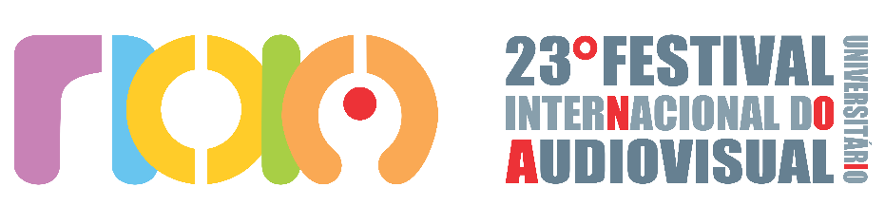

DECLARATION OF PARTICIPATION IN THE 23rd NOIA — INTERNATIONAL UNIVERSITY AUDIOVISUAL FESTIVAL
TERMS OF AUTHORIZATION FOR THE USE OF IMAGE AND GRANT OF EXHIBITION RIGHTS
AUTHORIZATION FOR THE USE OF IMAGE: We grant the organizers of the NOIA Festival, free of charge, the right to use the image and audio of the director and other technical crew members, exclusively for the promotional or journalistic dissemination of the Festival (in physical or virtual formats), for this and future editions.
GRANT OF EXHIBITION RIGHTS: We authorize the exhibition of the submitted short film in all activities related to the NOIA Festival, including its promotion. This authorization is non-exclusive and valid for a period of 3 (three) years, starting from the date this document is signed. During this period, the NOIA Festival may exhibit the work on the following platforms and as part of the following activities:
- Festival Activities: In-person screenings at public and private venues, as part of the official program.
- Virtual Platforms: The Festival’s official channels on YouTube and on streaming platforms aimed at academic and student audiences.
- Cultural and Itinerant Actions: Screenings as part of Festival projects and showcases with a strictly academic, cultural, and social purpose.
The NOIA Festival will not commercialize the selected or awarded short film.
- LEGAL RESPONSIBILITY: We assume full and exclusive responsibility, including the right of recourse, for any dispute related to plagiarism or other violations of copyrights, image rights, and/or third-party rights.
- COMMUNICATION: We will consider all communications made through the contact details of the person responsible for the submission to be valid and effective. We commit to keeping this information up to date, under penalty of forfeiting any right to a claim due to a lack of knowledge of communications.
FORUM: For all purposes, the jurisdiction of the Court of Fortaleza, Brazil, is hereby elected.

RESPONSIBLE FOR THE FILM:
FILM TITLE: ____________________
LOCATION (CITY/STATE): _______________________
NAME: _____________________
CPF (Brazil) / National ID Number: _____________________
DATE /___________/ 2025.

SIGNATURE:

